Workington parade route
Sunday 10th November 2024
From 2pm
Parade route

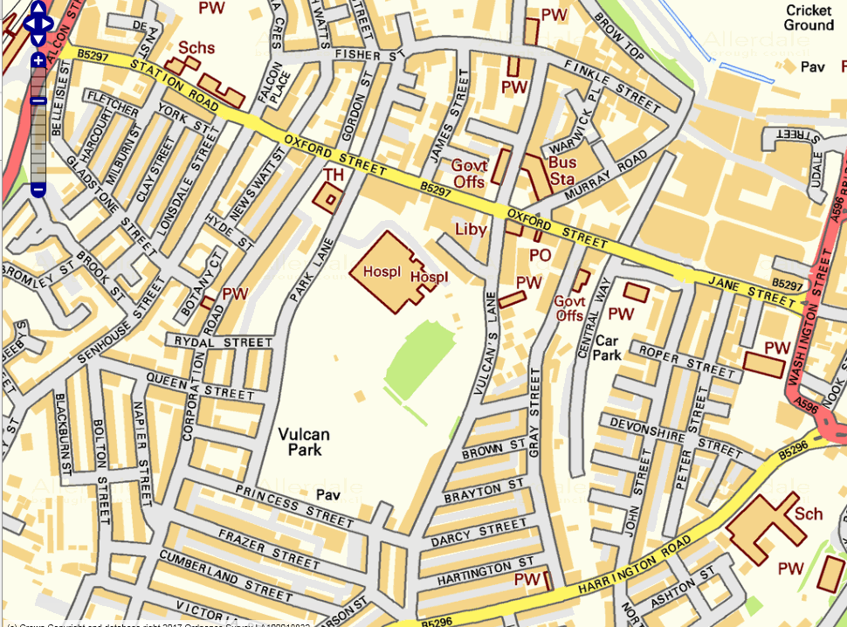
Parade Route
The Parade will move off from Pow Street onto Finkle Street, turning left onto Vulcan’s Lane and proceed to Vulcan Park, arriving at the Cenotaph at approximately 2.15pm where a service and wreath laying ceremony will take place.
The parade will leave Vulcan Park via Park Lane and head onto Corporation Road towards Oxford Street where The Mayor will take the salute outside the Town Hall.
The parade will then continue down Oxford Street onto Jane Street and ‘fall out’ by the car park entrance to the Royal British Legion. The parade will not go into the car park.
Pie, peas and gravy provided by Workington Town Council at the Royal British Legion afterwards.

