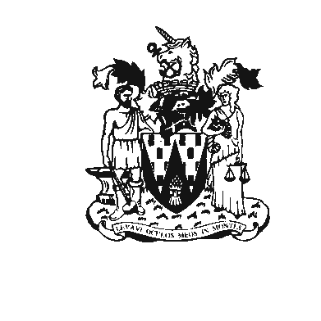
Workington Town Council
Town Hall, Oxford Street, Workington, CA14 2RS
Telephone: 01900 702986
Email: office@workingtontowncouncil.gov.uk
Website: www.workingtontowncouncil.gov.uk

SUNDAY 10 NOVEMBER 2024

HARRINGTON
REMEMBRANCE DAY PARADE

Parade Organiser
The parade is organised by Workington Town Council and supported by the Royal British Legion. If you have any questions or need further information, please contact:
- Emma Chapman, Workington Town Council: 07483 029158.
- Royal British Legion - Workington Branch: 01900 66834.

Wet Weather
In the event of extreme weather conditions, there will be no parade, the Church service will take place as normal.
Information will be posted on the Town Council’s Facebook page to inform everyone of any changes to arrangements. Please follow www.facebook.com/workingtontowncouncil for updates.
If you wish to be directly notified by text/Whatsapp please message Emma Chapman on 07483 029158.

Assembly
All formations are to assemble outside the Royal British Legion, Harrington at 9.30am and will come under the command of the Parade Marshal, SMI Stephen Petitt.

The Parade will March Off at 9.40am.

Order of March
- Band (if available)
- Civic VIPs (Lord Lieutenant, High Sheriff, Mayor, Councillors, MP)
- Clergy and/or choir
- Union Flag
- The Duke of Lancaster’s Regiment (reserves and serving personnel from all sections)
- Royal British Legion (RBL) and RBL Women's Section (RBLWS) Standards
- Standards of other ex-Service associations (RNA, Army, RAFA)
- Regular forces (Royal Navy (RN), Army, Royal Air Forces (RAF)
- Reserve forces
- Ex-Service contingents (preferably in one group, but may be in columns by Service and corps, normally with the Legion leading though there may be variations)
- Uniformed public services (police, fire brigade, ambulance services, St John Ambulance, Red Cross etc)
- Youth organisations (led by Service cadets, then uniformed organisations followed by non-uniformed bodies)
- Members of the public

Parade Route
- Assemble at the Harrington Royal British Legion Club at 9.30am.
- Move off at 9.40am.
- Arrive at St Mary’s Church at 9.50am. The service will be led by Revd. Dominic de Mattos.
- Service in St Mary’s Church from 10am to 10.45am.
- Move outside Church to the Cenotaph for short service.
- Parade back to the Harrington Royal British Legion Club at approximately 11.15am.
- Free pie, peas and gravy will be served for everyone after the parade finishes at Harrington Royal British Legion.

Conduct during parade
The parade is part of the Act of Remembrance and offers an opportunity for quiet reflection. Please be mindful of the nature of the parade and keep discussions to a minimum. Please do not leave the parade on route unless for an emergency. All participants who are able should complete the parade in full and fall-out at the Royal British Legion.

Dispersal
On the conclusion of the parade, all participants are invited to the Royal British Legion, Harrington for free pie, peas and gravy provided by Workington Town Council.

Wreaths
Organisations / representatives are responsible for pre-ordering and collecting their wreaths from the Royal British Legion before the day of the parade. Organisations / representatives should bring their wreaths to the start of the parade on Pow Street. Wreaths will be laid at the Cenotaph in Vulcan Park.

ORDER OF WREATH-LAYING
- Lord Lieutenant and/or Deputy Lieutenant
- Mayor of Workington
- Any other civic VIPs
- Representatives of regular forces
- Representatives of the territorial and reserve forces
- Representatives of ex-Service associations, including the Royal British Legion and the Women’s Section
- Representatives of uniformed public services (Police, Fire Brigade, Ambulance services)
- Representatives of uniformed voluntary services (St John Ambulance, Red Cross, etc.)
- Representatives of cadet forces
- Representatives of youth organisations
- Members of the public

Standard Bearers
At the Cenotaph, all Standards will be dipped on the first note of the “Last Post” and raised on the first note of “Reveille”; they will be dipped again in the Salute to the playing of the “National Anthem”. This will take place at the Cenotaph in Harrington churchyard.

When the parade has been halted, the Standards will be ordered to fall-out. This will happen outside of the Royal British Legion, Harrington.

